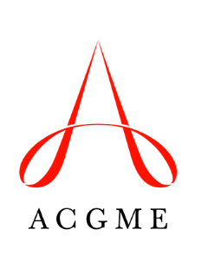
ACGME Rural and Underserved GME Advisory Group
Disclosure Form

☐ I confirm that I am not employed by the ACGME.
☐ I confirm that I am not related to anyone who is employed by the ACGME.
☐ I have no financial or non-financial relationships with the ACGME to report.
☐ I have the following financial and/or non-financial relationship(s) to report:

Name Date

